The "Street Chemist" Part-3
Atoms & Elements Putting Them Together to Form Compounds
ROBERT BURKE
Chemical Bonding
The first two installments of The Street Chemist dealt with the atom, the basic building block of our World, as we know it and the Periodic Table and Elements, which make up everything on Earth. Some elements are hazardous materials in their elemental form, while most other hazardous materials are made up of combinations of atoms of elements formed into compounds. There is a rule in nature that expects every element to reach satisfaction or stability through bonding with its self or other elements. Elements of family eight on the periodic table, the noble gases are an example of this stability. In the case of the noble gases, they exist naturally in a satisfied state, they already have two or eight electrons in their outer shell. All other atoms strive to become like the noble gases. Stability is reached through the process of chemical bonding. Forming compounds involves the bonding of atoms of elements. Bonding between atoms of elements occurs in the outer shell of electrons of the atom. Elements bond in order to achieve 2 or 8 electrons in their outer shells, which is a stable configuration. Thus through the bonding process, the atoms of the elements have reached stability, and a compound has been formed. Some elements cannot by nature exist as one atom. They are referred to as the diatomic elements. They are oxygen, hydrogen, nitrogen, fluorine, chlorine, bromine, and iodine. When found in nature, there are always two atoms of these elements bonded together. That is why oxygen is sometimes referred to as O2.
Ionic Bonding
There are two types of chemical bonds, ionic and covalent. Ionic bonds involve the bonding of a metal and a non-metal, which forms a salt compound. During ionic bonding, the outer shell electrons are exchanged between the atoms of the elements in the salt compound. Metals by nature, will give up their outer shell electrons to the non-metal. When the outer shell electrons of the metal are given up, the next shell becomes the outer shell and has 2 or 8 electrons in that shell. Non-metals will take the outer shell electrons from the metal and with the electrons they already have, will obtain a complete outer shell of electrons. When atoms of elements bond to form a compound, the compound may or may not carry over hazards of the elements. In some cases, hazardous elements can bond to form relatively non-hazardous compounds. For example, chlorine is a poison gas. Sodium is a water reactive metal. When bonded ionically, they form the salt compound sodium chloride, which is table salt. Table salt taken in moderation is not poisonous, and dissolves in water without the violent reaction of sodium metal when it contacts water. While sodium chloride does not pose a particular hazard in emergency response, washing it into a farmer's field could cause soil pollution that would render the field useless for years. Washing it into a fresh water source could cause damage to the aquatic life in that body of water
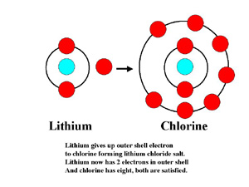
Ionic bonded lithium chloride graphic
Salt compounds can be divided into families. Just as families of elements on the periodic table have similar characteristics, so do families of compounds such as the salts. There are six salt families, which are important in the study of hazardous materials chemistry. They are the binary, binary oxide, peroxide, hydroxide, cyanide, and oxy salts. Each family has characteristics, which determine the naming of the salt compounds within the families, and thus the identification, and the hazards associated with each of the salt families. Hazards of salts range from environmental to water reactions, heat production, and release of oxidizers. The salt families and their hazards will be discussed further in the next installment.
Covalent Bonding
Covalent bonding takes place between atoms of non-metal elements. Electrons are shared rather than exchanged. Bonding still occurs to complete the outer shells of the non-metal compounds but the electrons never actually leave the element they begin with. When atoms bond covalently they form compounds referred to as non-salts. Major families of non-salt compounds include the inorganic acids, hydrocarbons and hydrocarbon derivatives. Inorganic acids contain hydrogen and some other non-metal element. They are recognized because they contain hydrogen as the first element in the molecular formula. The hazard of inorganic acids is corrositivity. Hydrogen and carbon are two very common non-metals that bond covalently to form compounds. Hydrogen has one electron in its outer shell to share in a compound. Carbon has four outer shell electrons to share. Many times carbon will bond with other atoms of carbon to form carbon chains, which are filled in with hydrogen to obtain complete outer shells. These hydrogen-carbon bonds are the characteristic of the hydrocarbon family of non-salts. When just hydrogen and carbon covalently bond together, four different families of compounds can be formed. They include the alkanes, alkenes, alkynes, and aromatic families. As with the salt families, each member of a hydrocarbon family has similar characteristics to the other family members. Generally, hydrocarbon family hazards are flammability and some may polymerize. Hydrocarbon derivatives are formed from hydrocarbon compounds when other non-metal elements are attached to hydrocarbons. Usually the non-metal elements found attached to form hydrocarbon derivatives include oxygen, nitrogen, chlorine, fluorine, bromine, and iodine. Ten primary hydrocarbon derivative families are formed from combining the above elements with hydrocarbons. They include the alkyl halide, nitro, amine, ether, peroxide, alcohol, ketone, aldehyde, ester, and organic acid families. Hazards of the hydrocarbon derivative families range from poison to flammable, oxidizer, explosive, polymerization, and corrosive. Hydrocarbon derivative families will be discussed in detail in future months.
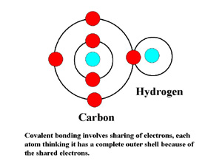
Covalent bonding graphic
Formulas
Once compounds are formed, they are identified by the name of the compound and by several types of formulas. A single element is the smallest portion of a chemical compound that can be encountered. Chemical compounds are made up of two or more elements in covalent or ionic bonds. Chemical compounds are represented by formulas just as elements are represented by symbols. According to the Condensed Chemical Dictionary, "a formula is a written representation using symbols of a chemical entity or relationship." There are three kinds of chemical formulas: empirical, molecular, and structural. Empirical formulas indicate composition, not structure, of the relative number and the kind of atoms in a molecule of one or more compounds, e.g., CH is the empirical formula for both acetylene and benzene. The molecular formula shows the actual number and kind of atoms in a chemical entity, e.g., the molecular formula for sulfuric acid is H2SO4. The molecular formula for propane would be C3H8. Molecular formula's are like a recipe for making the chemical compound. The structural formula indicates the location of the atoms in relation to each other in a molecule as well as the number and location of chemical bonds. Families, hazards, and formulas for salts, hydrocarbons, and hydrocarbon derivatives will be discussed in the coming months.
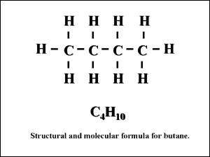
Graphic of structural formula

