The "Street Chemist" Part-9
Hydrocarbon Derivatives Nitro Compounds
ROBERT BURKE
Nitro compounds are the second of ten hydrocarbon derivative families. Their major hazard is explosive. Nitrogen and oxygen make up the nitro functional group. Nitrogen has three bonding sites.
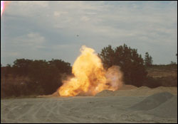
Robert Burke
Nitro Compounds are Explosive
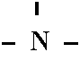
Two of those sites are taken up by two oxygen atoms, which are attached to each other. The other site is attached to a hydrocarbon radical.
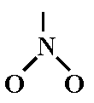
Nitro compounds are composed of one hydrocarbon radical attached to one or more nitro functional groups. Oxygen-to-oxygen single bonds are very unstable and reactive. This same bond is present in the organic peroxide family and in ether compounds as they age and form explosive peroxides inside the container. Some common nitro compounds include nitro methane, nitro benzene, tri-nitro toluene, nitroglycerin and tri-nitro penol. Nitro compounds have other hazards besides explosive. It is however, the explosive hazard that causes most concern. Some nitro compounds such as nitro benzene are not by themselves considered explosive.
Nitro methane is a dangerous fire and explosion hazard and moderately toxic by inhalation and ingestion. The tolerance is 100 ppm in air. It is also flammable with an LEL of 7.3% and a flash point of 95° F. Nitro methane is used as a rocket fuel and a gasoline additive. It is classified as a flammable liquid by DOT. Nitro methane's molecular formula is CH3NO2 and the structure is shown below.
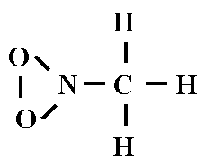
Nitrobenzene is flammable, but has a high flash point of 195º F, but it is also toxic by ingestion, inhalation, and skin contact. The tolerance is listed as 1 ppm. Nitrobenzene is classified by DOT as a poison. Nitrobenzene has a molecular formula of C6H5NO2 and the following structure.
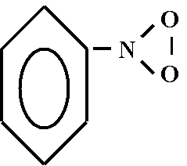
Tri-nitro toluene, also known as TNT, is a dangerous high explosive. TNT is toxic by ingestion, inhalation, and skin contact. The tolerance is 0.5 mg/m3 of air. It is flammable, and will detonate if vigorously shocked or heated to 450º F. TNT is classified by DOT as an Explosive 1.1. If wetted with not less than 10% water, it can be shipped as a flammable solid. The molecular formula for TNT is CH3C6H2(NO2)3 and the structure is shown below.
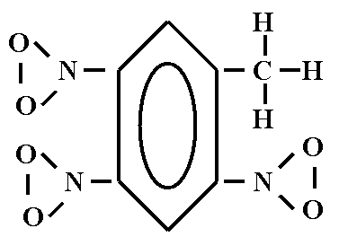
Tri-nitro phenol, also known as picric acid, is a high explosive when dried out. It is toxic by skin absorption, with a tolerance of 0.1 mg/m3 of air. Picric acid is shock and heat sensitive and reacts with metals or metallic salts. DOT classifies picric acid as an explosive 1.1. It can also be shipped as a wetted explosive and carry a flammable solid classification if combined with not less than 10% water. Picric acid is often used in high school and college chemistry labs in the wetted form. As the picric acid ages, the water evaporates from the container leaving the high explosive form. If found in the high explosive form in a lab or elsewhere, the bomb squad should be contacted to dispose of the picric acid. The molecular formula for picric acid is C6H2(NO2)3OH and the structure is shown below.
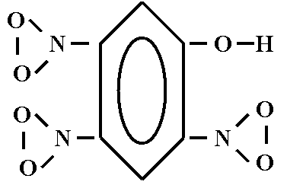
Nitroglycerin is a high explosive and is highly sensitive to shock and heat. It is highly toxic by inhalation, ingestion, and skin absorption. It has a tolerance of 0.02 ppm in air. DOT classifies nitroglycerin as an Explosive 1.1 and requires it be desensitized before it can be shipped in transportation. The molecular formula for nitroglycerin is CH2NO3CHNO3CH2NO3 and the structure is shown below.
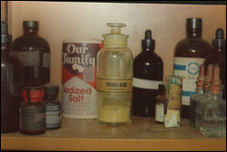
Robert Burke
Very dry picric acid found in high school chemistry lab
