The "Street Chemist" Part-8
Hydrocarbon Derivative Families Alkyl Halide
ROBERT BURKE
There are ten hydrocarbon derivative families, which are important to hazardous materials responders. Understanding the family characteristics and hazards can assist responders when first on the scene. It is still critically important that personnel thoroughly research hazardous materials to determine chemical and physical characteristics of the individual chemicals to develop response tactics. Concepts of "Street Chemistry" are intended for initial response quick reference and to help responders understand information obtained from research resources.
Hydrocarbon derivative families all have general hazards associated with each family. Some compounds may not possess all of the family hazards, but if responders can identify the family, they can determine those hazards, which may be present and those that are not.
Alkyl halide is the first of the hydrocarbon derivative families. As a group, they are composed of carbon and hydrogen with one or more of the halogens attached to form a compound. This means that a hydrocarbon radical will be attached to fluorine, chlorine, bromine, or iodine. Some alkyl halides may have more than one halogen in the compound or more than one atom of the same halogen. Alkyl halides are either flammable or toxic; there are however, some, which are neither flammable nor overly toxic. Halon fire extinguishing agents are from the alkyl halide family. The general formula for alkyl halides is R - X. The "R" represents any hydrocarbon radical and the "X" represents any of the halogens.
Naming alkyl halides can at best be a little tricky and sometimes downright confusing. The problem is there are two correct naming conventions, complicated by trade names. First, alkyl halides can be named using the hydrocarbon derivative and follow with the halogen name. If the radical used were the methyl radical, the radical name would be "methyl". The halogens are then named and the ending "ide" is added to the halogen. For example, if chlorine would be the halogen used in a compound, the halogen name would be "chloride". If fluorine was used it would be fluoride, and so on. Therefore, a compound with the methyl radical and chlorine would be called methyl chloride. The structure and molecular formula for methyl chloride are shown below.
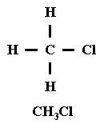
When more than one atom of the same halogen is used in a compound, the prefixes "di" for two, "tri" for three, and "tetra" for four are used in front of the halogen name. So, if two chlorine atoms were used in a compound with a methyl radical the compound name would be methyl dichloride. If three chlorine atoms were used the name would be methyl trichloride; four would be methyl tetrachloride. The structure and molecular formula for methyl trichloride is shown below. Methyl trichloride is also known by the trade name chloroform.
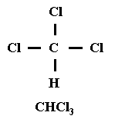
Different halogen atoms can also be used in the same compound. If the radical contained two carbons, the radical name would be "ethyl". Adding the halogens chlorine and two bromine atoms would result in the halogen names chloride and dibromide. However, since there are two halogens, the first one is changed to chloro, which makes the name flow more smoothly. The compound would be named ethyl chloro dibromide.
Generally, when there is more than one type of halogen atom, they are named in the order in which they appear on the Periodic Table of Elements. Shown below is the structure and molecular formula for ethyl chloro dibromide.
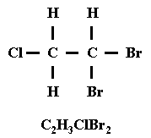
Alkyl halide compounds can also be named using the halogen name first and the hydrocarbon radical second. If an iodine atom is attached to a three carbon radical, the name for the iodine would be "iodo", again using the "o" to make the name flow smoothly. A three carbon radical comes from propane. When the radical is named second, it retains its original hydrocarbon name. So, iodine and propane combined would be called iodo propane. The structure, molecular formula, and alternate name for iodo propane is shown below.
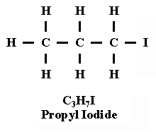
Multiple halogen atoms can also be attached using the alternate naming system. If fluorine and chlorine were added to the butyl radical, the fluorine and chlorine would be named first. Following the order on the Periodic Table the name would be fluoro chloro and end with the radical butane. The name would then be fluoro chloro butane. The structure, molecular formula, and alternate name are shown here.
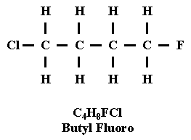
Halon is a fire-extinguishing agent, which has been found to be harmful to the Earth's ozone layer. It is no longer used in new installations of fire extinguishing systems. It is however, still in service in buildings around the country. Halon is an alkyl halide hydrocarbon derivative. Carbon tetrachloride is one of the first halon agents. It is no longer used as a fire-extinguishing agent because it forms phosgene gas when in contact with heated surfaces. Halons are designated by numbers, like Halon 1301 and Halon 1211. They also have names, which follow the alkyl halide naming conventions. For example, Halon 1301 is methyl trifluoro bromide and Halon 1211 is methyl difluoro chloro bromide. The numbers in the halon name are actually a short hand for the atoms of elements in the compounds. Carbon is represented by the first number in the halon numbering system, followed by fluorine, chlorine, and bromine. This concept is illustrated in the following graphic.
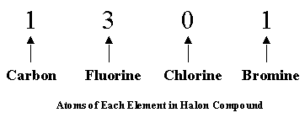
Therefore, Halon 1301 has one carbon atom, three fluorine atoms, no chlorine, and one bromine atom. The alternate naming convention can also be used for the halons just like other alkyl halides. Methyl trifluoro Bromide can also be called Triflouro bromo methane. Halon 1211 is methyl difluoro chloro bromide. The alternate name is Difluoro chloro bromo methane. Both halon 1301 and 1211 are non-flammable fire extinguishing agents and relatively non-toxic. The structures and molecular formulas for halon 1301 and halon 1211 are shown below.
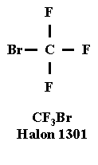 | 