The "Street Chemist" Part-6
Families of Non-Salt Compounds Part II - Aromatic Hydrocarbons
ROBERT BURKE
In the previous segment of the "Street Chemist" the hydrocarbons families, alkanes, alkenes, and alkynes were presented. They are all similar in terms of structure, molecular formulas, recognition, naming, and hazards. The final hydrocarbon family is the aromatic hydrocarbons, sometimes referred to as the "BTX" Fraction. Four members of the aromatic family will be discussed; they are benzene, toluene, xylene, and styrene.
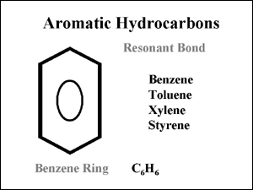
Courtesy Robert Burke
As a group, aromatic hydrocarbons are toxic and flammable. Benzene has also been designated as a carcinogen. Aromatic hydrocarbons are quite different from the first three families of hydrocarbons. One of the primary differences is the unique structure and bonding configuration, referred to as resonant bonding. Structurally, benzene is a ringed compound. There are six atoms of carbon in a ring with six atoms of hydrogen attached to each of the six carbons. This is reflected in the molecular formula for benzene, which is C6H6. Benzene is represented by the characteristic "benzene ring". The fourth connection required by carbon to gain stability with eight electrons in the outer shell would seem to be met by three double bonds in the center of the ring.
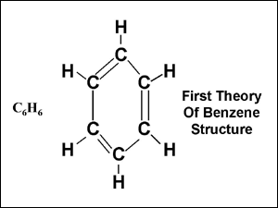
Courtesy Robert Burke
Bonds with in the aromatic compounds still consist of covalent bonds, sharing of electrons. However, the resonant bonding process itself is deceiving. The parent member of the aromatic compounds is benzene. Using the first theory of the behavior of benzene, it appears by looking at the structure of the benzene ring that there are three double bonds. Three double bonds would indicate a high degree of reactivity, much like the alkenes and alkynes. Benzene would appear to be unsaturated. Despite the appearance, the benzene ring structure is in fact quite stable. It is so stable in fact, that aromatics burn with a high degree of incomplete combustion. To explain this seemingly conflicting structure and behavior, the resonant bonding theory was developed. Using the resonance theory, since benzene is unreactive, it is believed that there are no double bonds in the center of the benzene ring. Instead, there are six electrons in the center of the ring in a state of resonance. That is to say, the electrons are not attached to any one carbon, but rather travel around in a state of resonance, much like a distributor in an older automobile. They travel so fast that each carbon thinks it has one of the electrons. This resonant bond is represented within the benzene ring by a large circle. Many times the benzene ring is shown in a "short hand" form where only the ring structure with the resonant circle is shown. The six carbons and six hydrogens are not always shown. Just be sure to remember that they are there when using the short method. When other aromatic compounds are made, one of the hydrogens on the benzene ring must be removed in order to attach other components. This occurs because benzene is a saturated compound.
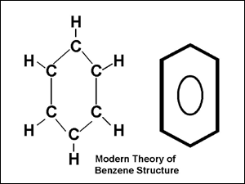
Courtesy Robert Burke
The second member of the aromatic family is toluene, sometimes referred to as methylbenzene or phenylmethane. Toluene is composed of a benzene ring with a methyl radical attached. This is accomplished by removing a hydrogen atom from benzene and methane. They are then bonded together at the point where the hydrogen was removed. Toluene has similar characteristics to benzene, however it has not yet been listed as a carcinogen. Primary differences between benzene and toluene are the physical characteristics such as boiling point, flash point, and ignition temperature. Toluene is not quite as toxic in terms of exposure limits as benzene. The molecular formula for toluene is C7H8. It can also be expressed as C6H5CH3.
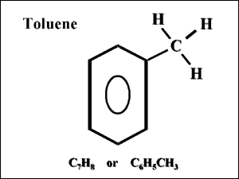
Courtesy Robert Burke
Xylene is the third of the aromatic hydrocarbons. It is sometimes referred to as dimethylbenzene. Xylene is actually a mixture of its three isomers, ortho zylene, meta zylene, and para xylene. Like toluene, it is composed of a benzene ring, but there are two methyl radicals attached. Two hydrogen atoms are removed from the benzene ring and two methyl radicals attached where the hydrogen atoms have been removed. The molecular formula for xylene is C8H10 or CH3C6H4CH3 or C6H4(CH3)2.
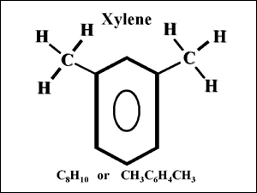
Courtesy Robert Burke
It is the location of the attached methyl radicals that determines the xylene isomer. Once again, the primary difference between benzene, toluene, and xylene is in physical characteristics. The isomers of xylene also have different physical characteristics. The reason for the different compounds derived from benzene is the commercial value. That is to say that something commercially useful can be made by changing the structure and physical characteristics of aromatic compounds. Regardless of the isomer of xylene, by definition of an isomer, the same formula but a different structure, all have the same molecular formula. The difference is in the structure and the location of the methyl radical on the structure. In order to identify the structure or isomer of xylene, a small m, o, or p are placed in front of the molecular formula. In the name of the compound, the prefix meta, ortho, or para are used. The structures for each are shown below.
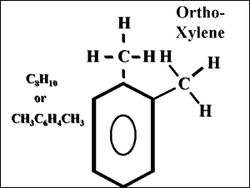
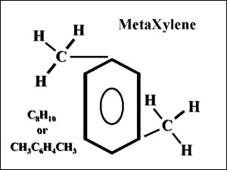
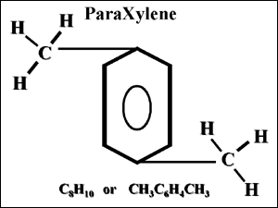
Courtesy Robert Burke
Styrene is the last of the aromatic hydrocarbons. Styrene is a monomer, a compound used to make some types of plastics. Once again, a single hydrogen is removed from the benzene ring and the vinyl radical added. Unlike benzene, toluene, and xylene, styrene is reactive, but not because of the benzene ring, rather the vinyl radical attached to the benzene ring. The vinyl radical contains one double bond, which provides the reactivity and allows for polymerization to take place. Polymerization is a reaction that occurs within a chemical when double bonds brake and the molecules formed attach to each other. Under controlled conditions, that process is used to make plastics. Styrene is flammable and must be inhibited during transportation. Inhibitors are chemicals used to ship polymers in to keep them from undergoing an uncontrolled polymerization reaction during shipment.
Hydrocarbon compounds are among the most common of all hazardous materials. They are also used as the backbone to make other hazardous materials called hydrocarbon derivatives. Hydrogen will be removed from hydrocarbon compounds creating radicals. Radicals are formed from alkanes, alkenes, and aromatic hydrocarbon compounds. Elements other than hydrogen and carbon will be attached to the radicals making up a hydrocarbon derivative. These elements include oxygen, nitrogen, fluorine, chlorine, bromine, and iodine. Together these few elements make up the largest section of hazardous materials in transportation, storage, and use today. Hydrocarbon derivatives can also be organized in to families. In the next segment of the "Street Chemist" we will start looking at hydrocarbon derivative families.
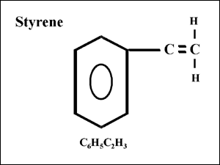
Courtesy Robert Burke

