The "Street Chemist" Part-5
Families of Non-Salt Compounds Part I - The Hydrocarbons
ROBERT BURKE
Elements bond together ionically or covalently to form compounds. Compounds can be organized into families, which have similar characteristics and hazards. If you are familiar with the rules that place a compound into a particular family, you can encounter an unknown compound and know the hazards based upon family association. Metals and non-metals bond together ionically to form salts. Non-metals and non-metals bond together covalently to form non-salt compounds. Two or more non-metals may be involved in the bonding process to form a compound. The most frequently encountered hazardous materials at incidents are made up of just a few of the non-metal elements. They are carbon, hydrogen, oxygen, sulfur, nitrogen, phosphorus, fluorine, chlorine, bromine, and iodine. Approximately 90% of covalently bonded hazardous materials are made up of carbon, hydrogen, and oxygen. The other 10% are composed of chlorine, nitrogen, fluorine, bromine, iodine, sulfur, and phosphorus.
As previously discussed, when atoms of elements bond together, they must end up with either 2 or 8 electrons in the outer shell. This is the duet and octet rule of bonding. This is also true of non-salt compounds. Salt compounds are ionically bonded together and exchange electrons to satisfy the rules of bonding. This results in a positive or negative charge to the atoms of the elements in the compound. Non-salt compounds bond covalently and do not exchange electrons; they share them. When electrons are shared, they are shared in pairs. Each atom of an element involved provides at least one electron to share in the covalent bond. The number of electrons that an element has to share is based upon the number of electrons in the outer shell, just like the salt compounds. As you will remember, this number is obtained from the top of the columns of the Periodic Table of Elements. For example, carbon is one of the backbone elements of organic compounds. Organic compounds are those, which contain carbon in the compound. Carbon has four electrons in its outer shell. Therefore, it has four electrons available to share with other elements. Another element, which is common in organic compounds, is hydrogen. Hydrogen has one electron in its outer shell to share with another element. Nitrogen has three electrons to share. Fluorine, chlorine, bromine, and iodine have one electron to share. Oxygen has two electrons to share.
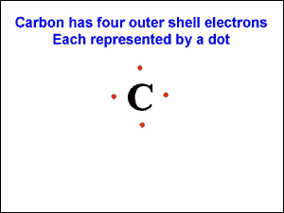
Courtesy Robert Burke
Salt compounds were represented by the name of the compound and the molecular formula. Non-salt compounds are also represented by the compound name and molecular formula. However, there is another type of formula used to also represent non-salt compounds; the structural formula. Since there is no exchange of electrons in covalent bonding, there are no charges on the elements. Therefore, the molecular formula represents the exact number of each element in the compound, much like a recipe identifies the components of a dish. The structural formula represents the type of bonding that takes place in the compound. Bonding occurs with the outer shell electrons. Electrons in a covalent bond can be represented by dots next to the element symbol in a compound structural formula. This is referred to as the electron dot method. Carbon had four electrons in its outer shell, so in the structural formula carbon would be represented by a capital "C" with a single dot on each of carbons four sides. The following drawing illustrates the electron dot configuration of carbon.
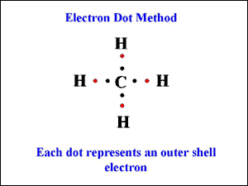
Courtesy Robert Burke
Hydrogen has one electron to share in a covalent bond. That single electron would be represented in a structural formula by the symbol for hydrogen, a capitol "H" and a single dot. When hydrogen bonds with carbon, it can only bond with one of carbon's four electrons. The single hydrogen now has a complete outer shell of two electrons, satisfying the duet rule of bonding. Hydrogen has one electron of its own and one shared with carbon. Carbon however, needs three more electrons to reach eight in its outer shell. Often times it is hydrogen that is used to complete carbon. This is where the family of hydrocarbons originates. They are compounds made up exclusively of carbon and hydrogen. Shown below is the electron dot configuration for a single carbon bonded to four hydrogen's.
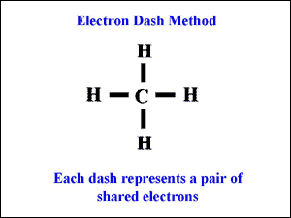
Courtesy Robert Burke
Another scientist came along and put forward the theory to represent each pair of shard electrons with a dash. It is the dash method, which is used today in representing the shared pair of electrons between elements. Shown below is carbon and hydrogen bonded together using the dash method.
When compounds are made up entirely of carbon and hydrogen, they are called hydrocarbons. The family of hydrocarbon compounds has four members, the alkane, alkane, alkyne, and aromatic families. Just as carbon and hydrogen can bond together, so can carbon and carbon. Often times with the hydrocarbons carbon will share one or more electrons with another carbon or carbons. When electrons are shared between two carbons, they are referred to as single, double or triple bonds. The type of bond determines which family the compound belongs to. The remaining bonds needed to complete the compounds occur between carbon and the necessary number of hydrogen electrons to satisfy the octet rule of bonding. Compounds with all single bonds are members of the alkane family. Those with one or more double bonds are alkenes. Finally, those with a triple bond are the alkyne family. Aromatics have a different bonding system and will be discussed later. The name of the hydrocarbon compound is determined by the number of carbons in the compound and the type of bond. The following chart shows the compound prefix used for certain numbers of carbons found in the compound.
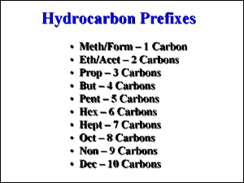
Courtesy Robert Burke
Alkane hydrocarbons all have single bonds between the carbons. They are considered saturated, because there is no more room to add any additional hydrogen. As a family they are all flammable. Hydrocarbons are named by the prefix denoting the number of carbons in the compound and end with the last three letters of the family name based upon the type of bonds. For example, a one-carbon alkane would be named "meth" for one carbon and ends with "ane" because the bonds are single. The compound would be called methane.
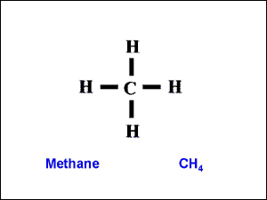
Courtesy Robert Burke
Alkene hydrocarbons have one or more double bonds between carbons in the compound. They are considered unsaturated, because double bonds can break to add atoms of other elements. They are also flammable like the alkanes. Double bonds found in the alkene family are quite reactive. When exposed to heat, friction, or shock, they can break apart and the compound can undergo a chemical reaction called polymerization. The same prefixes are used as for the alkanes. Then ending is "ene" representing the alkene family. There are no single carbon alkenes because double bonds will only work between carbons, not carbon and hydrogen. So, the first alkene is a two-carbon compound. Two carbons has a prefix of "eth" and a compound with a double bond ends in "ene". Therefore, a two carbon alkene is called ethene. Alkene compounds also exist with two double bonds. This must be indicated in the name. There also must be a minimum of three carbons for two double bonds to work. Generally, you will not find compounds with two double bonds right next to each other; it would be very reactive. So a four carbon alkene is much more likely to have a double bond. The prefix for four carbons is "but" and the ending would be "ene". However, the two double bonds must also be indicated in the name. The terms "di" for two, and "tri" for three are used to indicate the number of double bonds in the compound. So a four-carbon compound with two double bonds would be called butadiene. The "a" is added to make the name flow better. A six-carbon compound with three double bonds would be named hexatriene. Hex indicates six carbons, "tri" indicates three double bonds and "ene" indicates the alkene family.
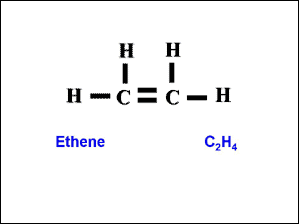
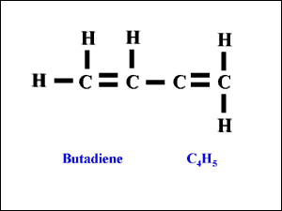
Courtesy Robert Burke
The final hydrocarbon discussed in this column will be the alkyne family. The aromatics will be discussed next time. Alkyne hydrocarbons have one or more triple bonds. They are unsaturated like the alkenes. They are also flammable. The same prefixes are used as for the alkane and alkene families. The ending is "yne" indicating a triple bond. While all of the rules that apply to the alkynes would allow you to make different compounds, there is really only one commercially valuable alkyne, and that is the two carbon compound ethyne. Ethyne is more commonly known by its trade name, acetylene. If double bonds are reactive, you can imagine that triple bonds are more reactive. That is why acetylene is so unstable and burns with almost any mixture of oxygen.
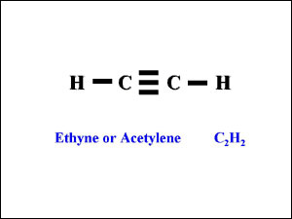
Courtesy Robert Burke

