The "Street Chemist" Part-13
Aldehyde Hydrocarbon Derivatives
ROBERT BURKE
Aldehydes are the next family of hydrocarbon derivatives. In the aldehyde family, most compounds are liquids, except for the one-carbon aldehyde, formaldehyde, which is a gas. Aldehydes have a wide flammable range from 3 to 55% in air; they are toxic and may polymerize. They have moderate boiling and flash points, and high ignition temperatures. Fires involving aldehydes should be fought with polar-solvent type foams because water may be ineffective. Aldehydes may also form explosive peroxides as they age much the same way ethers do.
Aldehydes are composed of a carbon double-bonded to oxygen with a hydrogen atom on the other carbon connection. Aldehydes are carbonyls and, therefore, polar. The degree of polarity is much the same as ketone and ester, and much less than alcohol and organic acid. They are miscible in water and require the use of polar-solvent foams to extinguish fires. Aldehydes have the general formula of R-CHO. There is one radical attached to the carbon of the aldehyde functional group. Aldehydes are one of the three derivatives in which the carbon in the functional group is counted when naming the compound. The alternate terms for one- and two-carbon radicals are also used with the aldehydes. A one-carbon aldehyde uses "form" and a two-carbon uses "acet" as a prefix. The aldehydes are named by identifying the radical, naming it, and ending with the word aldehyde. Aldehydes may also be named in the same manner as the alternate names for alcohols; however, with the aldehydes, the ending is "al" instead of "ol". For example, a one-carbon aldehyde is called formaldehyde with the alternate name of methanal. In the following examples, the structures, molecular formulas, physical and chemical characteristics, and names are shown for one-, two-, three-, and four-carbon aldehydes.
Formaldehyde, HCHO, is an aldehyde hydrocarbon derivative. Formaldehyde is a gas with a strong, pungent odor. It readily polymerizes. Commercially it is offered as a 37 to 50% solution, which may contain up to 15% methanol to inhibit polymerization. Boiling points for solutions range from 206º to 212º F. Commercial solutions have the trade name formalin. Formaldehyde is flammable, with a wide flammable range of 7 to 73% in air. The boiling point is -3º F, and the flash point is 185º F. The ignition temperature for the gas is 572º F. It is water-soluble. The vapor density is 1, which is the same as air. Formaldehyde is also toxic by inhalation, a strong irritant, and a carcinogen. The TLV is 1 ppm in air. Nonflammable solutions are Class 9 miscellaneous hazardous materials with a four-digit UN identification number of 2209. The NFPA 704 designation is health 3, flammability 2, and reactivity 0. Flammable solutions are Class 3 flammable liquids with a four-digit UN identification number of 1198. The NFPA 704 designation is health 3, flammability 4, and reactivity 0. The following structure is for formaldehyde:

Acetaldehyde, also known as ethanal, is a colorless liquid with a pungent, fruity odor. The odor is detectable at 0.07 to 0.21 ppm in air. It is highly flammable and a dangerous fire and explosion risk with a wide flammable range of 4 to 60% in air. The boiling point is 69º F, the flash point is -36º F, and the ignition temperature is 374º F. Acetaldehyde is miscible in water and the specific gravity is 0.78, which is lighter than water. The vapor density is 1.52, which is heavier than air. In addition to flammability, it is toxic (narcotic) and has a TLV of 100 ppm in air. Eye irritation occurs at 25 to 50 ppm in air. The four-digit UN identification number is 1089. The NFPA 704 designation is health 3, flammability 4, and reactivity 2. Its primary use is in the manufacture of other chemicals and artificial flavorings.
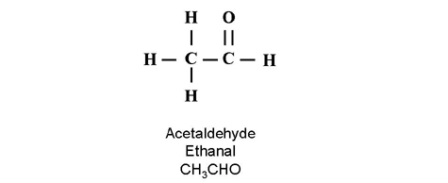
Propionaldehyde, also known as propanal and propylaldehyde, is a water-white liquid with a suffocating odor that is water-soluble. It is a dangerous fire and explosion risk with a flammable range of 3 to 16% in air. The boiling point is 120º F, the flash point is 16º F, and the ignition temperature is 405º F. It is partially soluble in water and has a specific gravity of 0.81, which is lighter than water. The vapor density is 0.807, which is lighter than air. In addition to flammability, propionaldehyde is an irritant to the eyes, skin, and respiratory system. The four-digit UN identification number is 1275. The NFPA 704 designation is health 2, flammability 3, and reactivity 2. The primary uses are in the manufacture of other chemicals and plastics, as well as a preservative and disinfectant. The structure and molecular formula for propionaldehyde is shown below.
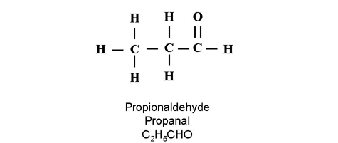
Butyraldehyde, also known as butanal, is a water-white liquid with a pungent aldehyde odor. Butyraldehyde is a dangerous fire risk, with a flammable range of 2.5 to 12.5% in air. The boiling point is 168º F, the flash point is 10º F, and the ignition temperature is 446º F. It is slightly soluble in water with a specific gravity of 0.8, which is lighter than water. The vapor density is 0.804, which is lighter than air. In addition to flammability, butyraldehyde is corrosive and causes severe eye and skin burns. It may be harmful if inhaled. The four-digit UN identification number is 1129. The NFPA 704 designation is health 3, flammability 3, and reactivity 2. The primary uses of butyraldehyde are in plastics and rubber, and as a solvent. The structure and molecular formula for butyraldehyde is shown below.
