The "Street Chemist" Part-12
Hydrocarbon Derivatives Alcohols
ROBERT BURKE
Alcohols
The next flammable liquid hydrocarbon derivative family is alcohol. In addition to being flammable, alcohols have wide flammable ranges from 1 to 36% in air, and are toxic to some degree. They have high boiling points, moderate flash points, and high ignition temperatures. Small fires involving alcohols should be fought with dry-chemical fire extinguishers. Large fires should be fought with alcohol-type foam; water may be ineffective. Alcohols are very miscible with water. Water, as it mixes with alcohol, will at some point raise the boiling and flash points of the alcohol until the mixture of the water and the alcohol are no longer flammable. The problem with this is that the container must be large enough to hold the mixture or this method of extinguishment will not work. Therefore, care must be taken in choosing the method of extinguishing alcohol fires. Methyl alcohol, or methanol as it is sometimes called, is toxic by ingestion and can cause blindness or death, with a TLV of 200 ppm. Ethyl alcohol or ethanol, also referred to as grain alcohol, is consumed in alcoholic beverages. It is classified as a depressant drug; too much of it can produce toxic effects and can lead to liver damage.
The alcohol functional group is identified by the general formula R-O-H. There is one radical attached to the oxygen atom. Alcohols are polar liquids because they have hydrogen bonding. Alcohol is the second-most polar functional group; the most polar are the organic acids. Because of polarity, alcohols are miscible with water and require the use of polar solvent or alcohol-type foam to extinguish fires. Because of polarity, alcohols as a family have high boiling and flash points. An alcohol is named by identifying the radical attached to the oxygen. The radical is named first and the compound ends in the word alcohol. There are often various ways of naming the same chemical compounds. With alcohol, an "ol" ending may be added to the radical, indicating that it is an alcohol. For example, the radical "methyl" is attached to the oxygen in the alcohol functional group. The name of the compound is methyl alcohol or may be called methanol.
Methyl alcohol also known as methanol and wood alcohol is an alcohol hydrocarbon derivative. It is a clear, colorless liquid that is highly polar and miscible in water. Alcohol has hydrogen bonding and is the second most polar material of the hydrocarbon derivatives after organic acids. It is a dangerous fire risk, with a wide flammable range from 6 to 36.5% in air. Fighting fires will require the use of alcohol-type foam. The boiling point is 147º F, and the flash point is 52º F. Notice from the following structure that the molecular weight of methyl alcohol is 32. It has only one carbon and one oxygen, yet the boiling point and flash point are high. The ignition temperature of methyl alcohol is 867º F. The effects of polarity can readily be seen in this example. In addition to being flammable, methyl alcohol is toxic by ingestion and has a TLV of 200 ppm in air. The vapor density is 1.1, which is heavier than air. The specific gravity is 0.8, which makes it lighter than water. Methyl alcohol is miscible in water so it will mix rather than form defined layers. The UN 4 digit identification number is 1230. The NFPA 704 designation is health 1, flammability 3, and reactivity 0. Methyl alcohol is shipped in glass bottles, 55-gal drums, tank trucks, and railcars. The structure and molecular formula for methyl alcohol are shown below.
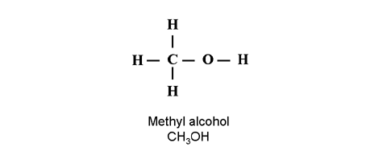
Ethyl alcohol, or ethanol, is a colorless, clear, volatile liquid. It is polar and soluble in water, with a specific gravity of 0.8, which is lighter than water. It is highly flammable with a flammable range of 3.3 to 19% in air. The boiling point is 173º F and the flash point is 55º F. The vapor density is 1.6, which is heavier than air. The ignition temperature is 685º F and ethanol is classified as a depressant drug with a TLV of 1000 ppm in air. The four-digit UN identification number is 1170. The NFPA 704 designation is health 0, flammability 3, and reactivity 0. The primary uses are as a solvent, in beverages, antifreeze, gasohol, pharmaceuticals, and explosives. The structure and molecular formula for ethyl alcohol are shown below.
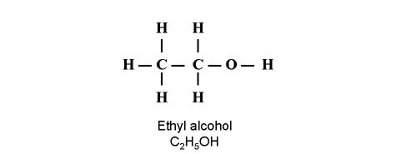
Propyl alcohol, 1-propanol, is a colorless liquid with an odor similar to ethanol. It is polar, soluble in water, and has a specific gravity is 0.8, which is lighter than water. It is a dangerous fire risk with a flammable range of 2 to 13% in air. The vapor density is 2.1, which is heavier than air. The boiling point is 207º F, the flash point is 74º F, and the ignition temperature is 775º F. It is toxic by skin absorption with a TLV of 200 ppm in air. The four-digit UN identification number is 1274. The NFPA 704 designation is health 1, flammability 3, and reactivity 0. The primary uses are in brake fluid, as a solvent, and as an antiseptic. The structure and molecular formula for propyl alcohol are shown below.
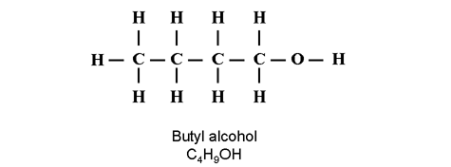
n-Butyl alcohol is an alcohol hydrocarbon derivative, and is a colorless liquid with a wine-like odor. Alcohols are highly polar and are miscible in water. Butyl alcohol is a moderate fire risk, with a flammable range of 1.4 to 11.2% in air. The boiling point is 243º F, the flash point is 98º F, and the ignition temperature is 650º F. Fires should be fought with alcohol-type foams. In addition to being flammable, butyl alcohol is toxic when inhaled for long periods, irritating to the eyes, and absorbed through the skin. The TLV is 50 ppm in air. The vapor density of butyl alcohol is 2.6, so it is heavier than air. The specific gravity is 0.8, which is lighter than water; however, it is miscible in water and will mix rather than form layers. The four-digit UN identification number is 1120. The NFPA 704 designation for butyl alcohol is health 1, flammability 3, and reactivity 0. It is shipped in glass bottles, pails, 55-gal drums, tank trucks, railcars, and barges. The structure and molecular formula for n-butyl alcohol is shown below.
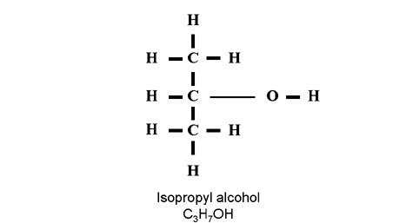
Isopropyl alcohol is an alcohol hydrocarbon derivative. The liquid is colorless with a pleasant odor, highly polar, and miscible in water. Firefighting will require polar-solvent foam for extinguishment. Isopropyl alcohol is highly flammable, with a flammable range of 2 to 12% in air. The boiling point is 181º F, the flash point is 53º F, and the ignition temperature is 750º F. In addition to flammability, isopropyl alcohol is toxic by ingestion and inhalation, with a TLV of 400 ppm in air. The vapor density is 2.1, which is heavier than air. The specific gravity is 0.8, which is lighter than water; however, it is miscible in water and will mix rather than form layers. The four-digit UN identification number is 1219. The NFPA 704 designation is health 1, flammability 3, and reactivity 0. It is shipped in glass bottles, pails, 55-gal drums, tank trucks, railcars, and barges. The structure and molecular formula for isopropyl alcohol are shown in the following example:
ISOMERS
Isomers were introduced in Chapter 4. An isomer is a compound with the same formula, but a different structure. Isomers are sometimes referred to as branched compounds. Branching of a compound has the effect of lowering the boiling point. In the Hydrocarbon section of Chapter 4, only the "iso" branch was discussed. With the hydrocarbon-derivative functional groups, there will also be an "iso" branch and, in addition, there will be secondary and tertiary branches. When dealing with the hydrocarbon compounds, the branch is a carbon attached to one of the center carbons of the chain. In the derivatives, the functional group is a part of that carbon chain and considered when determining branching of the compound. The types of branches will be shown in this section because they occur commonly with the alcohol compounds. However, branching can occur in any of the hydrocarbon derivative groups. Shown in the following illustration are examples of branches of a four-carbon alcohol. The branch is determined by the location of the functional group on the carbon chain. The first structure is the straight-chained compound butyl alcohol with a molecular formula of C4H9OH. Straight-chained compounds are sometimes referred to as the "normal" form. Normal butyl alcohol is represented by a small "n" in front of the compound name and molecular formula. The next structure is isobutyl alcohol. The "iso" branch is determined by locating the -O-H of the alcohol functional group and using it as an entry point into the structure, then go to the first carbon that is attached to the -O-H. See how many carbons are attached to the first carbon. In the case of the "iso" branch, only one carbon is attached. The third structure is secondary butyl alcohol. The -O-H is attached to a carbon that is attached to two other carbons. In the final structure, the compound is called tertiary butyl alcohol. The functional group is attached to a carbon that is attached to three other carbons. Notice that all of the compounds have the same molecular formula. To distinguish between them, it is necessary to include a small letter indicating which branch is in the structure. A small "i" is used for "iso" branches, a small "s" for secondary, and a small "t" for tertiary branches.
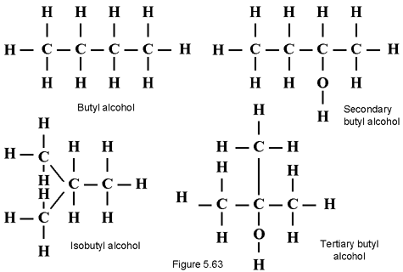
There is one exception to the branching rules of hydrocarbon derivatives. Propane cannot be branched as a straight hydrocarbon because there are not enough carbons to create a branch. However, in the derivatives, the functional group becomes a part of the carbon chain for the purpose of determining branching. It is possible to put a functional group of the center carbon of propane. The structure formed appears to be secondary, according to the examples above. However, there is only one-way to branch propane, so it is called the "iso" branch. That is something that has to be committed to memory as an exception to the branching rules. Another way to remember the exception is that secondary and tertiary are not used until there are four carbons in a compound. Iso-propyl alcohol is shown in figure 5.62. Denatured alcohol is ethyl alcohol or ethanol to which another liquid has been added to make it unfit to use as a beverage. The primary reason for denaturing is for tax purposes. There are approximately 50 formulations of denatured alcohol. The hazards are the same as for ethanol. The primary uses for denatured alcohol are in the manufacture of acetaldehyde, solvents, antifreeze, brake fluid, and fuels.

