The "Street Chemist" Part-11
Hydrocarbon Derivatives Ethers
ROBERT BURKE
Ethers
The next flammable liquid hydrocarbon derivative family is ether. The primary hazard of ether is flammability. Ethers have low boiling and flash points, wide flammable ranges, low ignition temperatures, and are non-polar. In addition to being flammable, ethers are anesthetic; they have wide flammable ranges, from 2 to 48% in air; and can form explosive peroxides as the ether ages. When a container of ether is opened, oxygen from the air gets inside and bonds with the oxygen in the ether, forming a very unstable peroxide. Heat, friction, or shock can cause the peroxide to explode. Oxygen has been known to permeate the soldered seam in a metal container even without the container being opened. Ethers can become very dangerous in storage. Most ether should not be stored longer than 6 months. If an aging container of ether is discovered, the nearest bomb squad should be called; the container should be treated as if it were a bomb. Ether compounds are composed of a single oxygen with two hydrocarbon radicals, one on either side of the oxygen. It is expressed by the general formula R-O-R. Ether names do not always follow the trivial naming system. However, the formula will have a single oxygen atom, which indicates the ether family. The radicals on either side of the oxygen may be the same or they may be different. Ether compounds are named by identifying the two hydrocarbon radicals and end the compound with the word ether. As a general rule, if the radicals are different, start with the smallest and name it, then name the second radical, and end with the word ether. For example, the following structure has a methyl radical and an ethyl radical on either side of the oxygen.
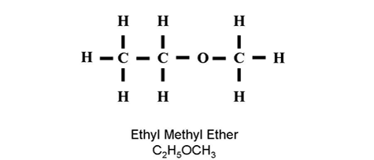
The smallest radical is methyl, the second radical is ethyl, and the name ends with ether. The name of the compound is methyl ethyl ether with a molecular formula of CH3OC2H5. There may be occasions when a compound is looked up in a reference book, but it is not listed by the trivial naming system. When this happens, just look it up using the other radical name, such as ethyl methyl ether. When the radicals on each side of the oxygen in the ether compound are the same, the compound is named with just the one radical name. No prefix is used to indicate two of the same radical. Because ether must have two radicals, and there is only one radical in the name, it is understood that there are two of the same radical. For example, methyl ether has two methyl radicals, one on each side of the oxygen. Ether is the only hydrocarbon derivative where the prefixe "di", indicating the number of radicals, is not used with the trivial naming system. However, even though uncommon, the "di" prefix is used and listed as a synonym for the common name of the ether compound. Therefore, it is not wrong to use "di" to identify the two radicals, it is just not common.
Ethyl methyl ether is a colorless liquid that is soluble in water. The specific gravity is 0.70, which is lighter than water. It is highly flammable, with a flammable range of 2 to 10.1% in air. The boiling point is 51º F, the flash point is -35º F, and the ignition temperature is 374º F. The vapor density is 2.07, which is heavier than air. In addition to flammability, ethyl methyl ether is anesthetic and can form explosive peroxides as it ages. The four-digit UN identification number is 1039. The NFPA 704 designation is health 1, flammability 4, and reactivity 1. The primary use is in medicine as an anesthetic.
Ethyl ether (diethyl ether) is a colorless, volatile, mobile liquid. It is slightly soluble in water with a specific gravity of 0.7, which is lighter than water. It is a severe fire and explosion risk when exposed to heat or flame. The compound forms explosive peroxides from the oxygen in the air as it ages. The flammable range is wide, from 1.85 to 48% in air. The boiling point is 95º F, the flash point is -49º F, and the ignition temperature is 356º F. The vapor density is 2.6, which is heavier than air. In addition to flammability, it is an anesthetic, which causes central nervous system depression by inhalation and skin absorption, with a TLV of 400 ppm in air. The four-digit UN identification number is 1155. The NFPA 704 designation is health 1, flammability 4, and reactivity 1. The primary uses are in the manufacture of smokeless powder, as an industrial solvent, in analytical chemistry, and as an anesthetic. The structure and molecular formula for ethyl ether is shown below.
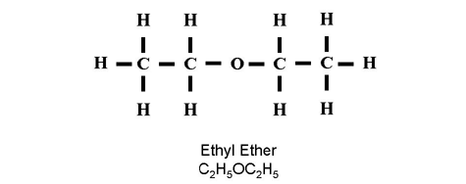
Isopropyl ether (diisopropyl ether) is a colorless, volatile liquid, which is slightly soluble in water. The specific gravity is 0.7, which is lighter than water. It is highly flammable with a wide flammable range of 1.4 to 21% in air. The boiling point is 156º F, the flash point is -18º F, and the ignition temperature is 830º F. The vapor density is 3.5, which is heavier than air. In addition to flammability, isopropyl ether is toxic by inhalation and a strong irritant, with a TLV of 250 ppm in air. The four-digit UN identification number is 1159. The NFPA 704 designation is health 1, flammability 3, and reactivity 1. The primary uses are as a solvent and in rubber cements. The structure and molecular formula for isopropyl ether is shown below.
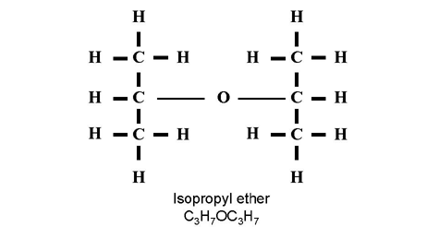
Butyl ether (dibutyl ether) is a colorless, stable liquid, with a mild ether-like odor. It is immiscible in water, with a specific gravity of 0.8, which is lighter than water. Butyl ether is a moderate fire risk and will form explosive peroxides on aging. The flammable range is 1.5 to 7.6% in air, with a boiling point of 286º F, and a flash point of 77º F. The ignition temperature is 382º F, and the vapor density is 4.5, which is heavier than air. In addition to flammability, butyl ether is toxic on prolonged inhalation. The four-digit UN identification number is 1149. The NFPA 704 designation is health 2, flammability 3, and reactivity 1. The primary use is as a solvent. The structure and molecular formula for butyl ether is shown below.
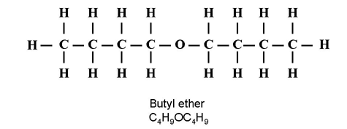
Methyl tert-butyl ether is an ether hydrocarbon derivative and is highly flammable with a wide flammable range. Methyl tert-butyl ether is not considered toxic; however, it is mildly irritating to the eyes and skin. If inhaled, it may cause suffocation. It is a gasoline additive and there has been some controversy concerning potential health effects. Methyl tert-butyl ether is added to gasoline as an oxygenating compound that makes gasoline burn cleaner in the winter. The Centers for Disease Control conducted a study that was inconclusive: it did not vindicate the material; it just did not find enough evidence that the chemical is a health concern. Methyl tert-butyl ether is a colorless, nonpolar liquid with an anesthetic-like odor. It has a boiling point of 131º F and a flash point of -14º F. Extinguishing agents for ethers and other nonpolar, nonmiscible, or slightly miscible liquids should be selected carefully. Small fires can be extinguished with dry chemical with some difficulty; remember that ether has an oxygen atom in the compound so excluding atmospheric oxygen may not be effective. Water may also be ineffective. Alcohol-type foams may be effective against materials that are slightly miscible. The higher molecular weight liquids will attack the alcohol-type foam and hydrocarbon foam will be needed. The vapor density is 3, which makes it heavier than air. The specific gravity is 0.74, which is less than the weight of water; therefore, it will float on top of water. Methyl tert-butyl ether has a four-digit UN identification number of 2398. It is used primarily as an octane booster for unleaded gasoline. There is no NFPA 704 data available for methyl tert-butyl ether and the reference information on the material is sketchy. No ignition temperature or flammable range information is available in the common reference sources, including CAMEO (Computer-Aided Management of Emergency Operations).
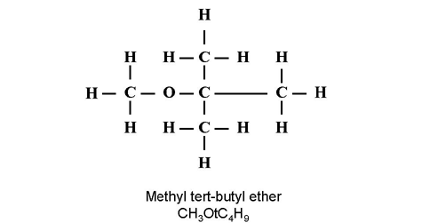
Propylene is a cyclic ether hydrocarbon derivative, although it does not follow the trivial naming system for ethers. It has a cyclic structure between the oxygen and two carbons and is a colorless liquid with an ether-like odor. Propylene oxide is non-polar, partially soluble in water, and is highly flammable, with a wide flammable range of 2 to 22% in air. The boiling point is 94º F, the flash point is 35º F, and the ignition temperature is 840º F. Small fires can be extinguished with dry chemical with some difficulty. Remember that ether has an oxygen atom in the compound; so excluding atmospheric oxygen may not be effective. Water may also be ineffective. Alcohol-type foams may be effective against materials that are slightly miscible. The higher molecular weight liquids will attack the alcohol-type foam and hydrocarbon foam will need to be used. In addition to flammability, propylene oxide is an irritant with a TLV of 20 ppm in air and it is also corrosive. The vapor density is 2, so it is heavier than air. The specific gravity is 0.83, which is lighter than water, and it will float on the surface. The four-digit UN identification number is 1280. The NFPA 704 designation for propylene oxide is health 3, flammability 4, and reactivity 2. It is shipped in steel cylinders, tank trucks, railcars, and barges under the cover of nitrogen, which is an inert material. The structure and molecular formula for propylene oxide are shown in the following illustration:
